General Welfare Requirement: Safeguarding and Promoting Children's Welfare
The provider must take necessary steps to safeguard and promote the welfare of children.
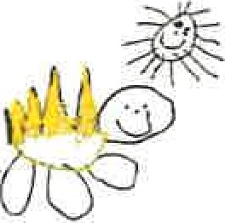
Gorran Pre School
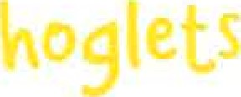
Safeguarding children

1.9 Maintaining children's safety and security on premises
Policy statement
At Gorran Pre-School Hoglets we maintain the highest possible security of our premises to ensure that each child is safely cared for during their time with us.
EYFS key themes and commitments
A Unique Child | Positive  Relationships | Enabling  Environments | Learning and  Development
1.3 Keeping safe | 2.2 Parents as partners

Procedures
Children's personal safety
We ensure all employed staff have been checked for criminal records by an enhanced disclosure from the Criminal Records Bureau.
- Adults do not normally supervise children on their own.
- All children are supervised by adults at all times.
Whenever children are on the premises at least two adults are present.
We carry out risk assessment to ensure children are not made vulnerable within any part of
Security
- Systems are in place for the safe arrival and departure of children.
The times of the children's arrivals and departures are recorded.
The arrival and departure times of adults - staff, volunteers and visitors - are recorded.
Our systems prevent unauthorised access to our premises.
- Our systems prevent children from leaving our premises unnoticed.
The personal possessions of staff and volunteers are securely stored during sessions.

Other useful Pre-school Learning Alliance publications

Managing Risk (2009)
This policy was adopted at a meeting of
Held on October 2019
Date to be reviewed October 2020
Name of signatory
Role of signatory (manager)

Gorran Preschool Hoglets

Michelle Beard

Pre-School Leader/Nominated Person

